Day 2 Intro to CSS

4:00 release slides

5:00

Send CSS class files to Jacob to see if it works

How can I send image files to students?

6:00 Start Class

Introduce new people (elbow lick)

Review Zoom hand raise feature

Go for a second monitor if you can

Spend 2 hours studying for each hour in class

Need to do homework and check in, can turn in late, but you don’t want to fall behind.

Tech course there is no grade, but may influence Corporate course

If you checked both homework under one spot just upload a note to the other one saying it is loaded in the other location.

Review Syllabus

Have Jacob Demo command line stuff

Installs

**Review install of Visual Studio**

Help > about

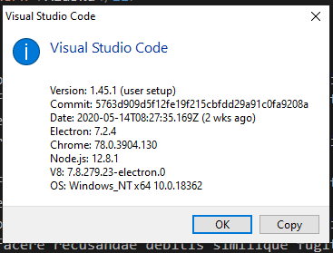

Link to install >>>> <https://visualstudio.microsoft.com/>

Visual Studio**Visual Studio**

[**Visual Studio IDE, Code Editor, Azure DevOps, & App Center - Visual Studio**](https://visualstudio.microsoft.com/)

Visual Studio dev tools & services make app development easy for any platform & language. Try our Mac & Windows code editor, IDE, or Azure DevOps for free.(391 kB)

<https://visualstudio.microsoft.com/wp-content/uploads/2020/03/Visual-studio-cloud-connected.png>

[9:46](https://tts-students.slack.com/archives/G0144PMK8BU/p1590630378015600)

Highlight the Download Visual Studio Code button and select the appropriate OS for your system.

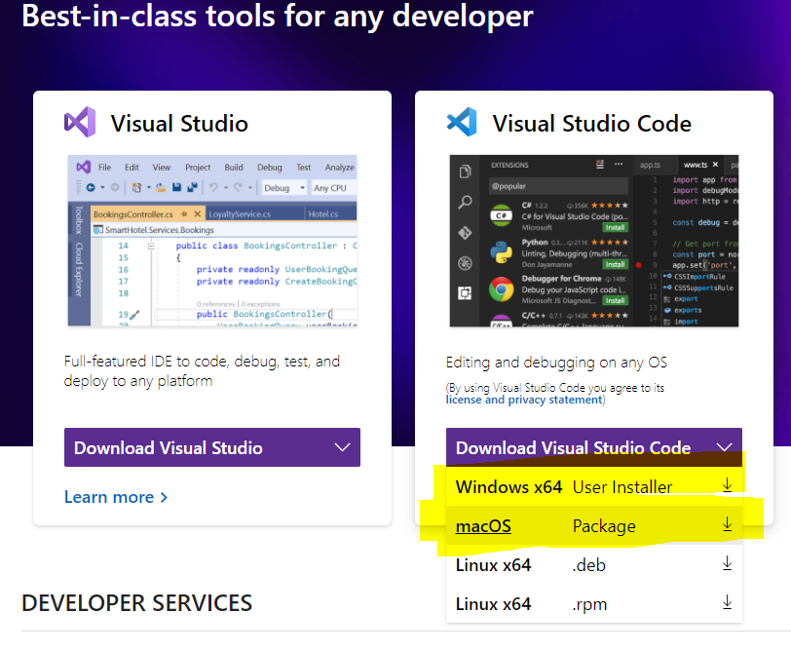

Live Server?

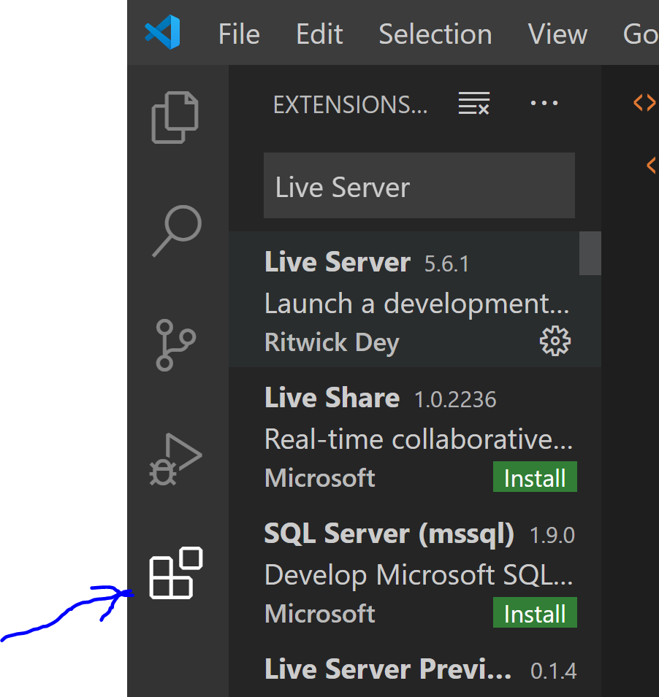

**Review Install of Chrome**

<https://www.google.com/chrome/>

Briefly walk through features of Developer tools

Inspect

Elements

Styles, show computed

6:20 HTML homework & review

Open “*Day 1-html_basics*” in VS

Need to do some homework, can do any or all of those listed. You learn more if you do them all.

You don’t want to fall behind, covering a lot of material for one course, watch videos

Who wants to share solution? (use small window)

Show <B> tag <https://developer.mozilla.org/en-US/docs/Web/HTML/Element/b>

Show contact page (not just one answer)

6:30 CSS Class

Create TTS/Day2-Intro to CSS directory

Open in VS

Create index.html (be sure it ends in .html)

<!DOCTYPE html>

<html>

<head>

<body>

Teach comment <!-- 🡪

Add content to index.html (playground)

<h1 id="top">Welcome to my Travel Site</h1>

<h2>Here are some places I'd like to visit</h2>

<ul>

<li>Spain</li>

<li>Italy</li>

<li>Aruba</li>

<li>Alaska</li>

</ul>

<h2>Why I love to travel</h2>

<p>Lorem ipsum, dolor sit amet consectetur adipisicing elit. Rerum repellat, facilis consectetur reprehenderit

aliquid quos facere recusandae debitis similique fugit, repudiandae minus. Tempore, nulla eos fugiat aliquid a

delectus neque.</p>

<p>Lorem ipsum, dolor sit amet consectetur adipisicing elit. Rerum repellat, facilis consectetur reprehenderit

aliquid quos facere recusandae debitis similique fugit, repudiandae minus. Tempore, nulla eos fugiat aliquid a

delectus neque.</p>

<p>Lorem ipsum, dolor sit amet consectetur adipisicing elit. Rerum repellat, facilis consectetur reprehenderit

aliquid quos facere recusandae debitis similique fugit, repudiandae minus. Tempore, nulla eos fugiat aliquid a

delectus neque.</p>

<h2>What makes a good traveler</h2>

<p>Lorem ipsum dolor sit amet consectetur adipisicing elit. Rerum laboriosam nam magnam delectus repudiandae! Quibusdam deserunt ratione ipsa, ducimus illum asperiores ipsam consectetur neque atque, facilis dignissimos quo aspernatur expedita.</p>

<table>

<tr>

<th>Destination</th>

<th>Capital</th>

<th>Official Language</th>

</tr>

<tr>

<td>Spain</td>

<td>Madrid</td>

<td>Spanish</td>

</tr>

<tr>

<td>Italy</td>

<td>Rome</td>

<td>Italian</td>

</tr>

<tr>

<td>Aruba</td>

<td>Oranjestad</td>

<td>Dutch</td>

</tr>

<tr>

<td>Alaska</td>

<td>Juneau</td>

<td>n/a</td>

</tr>

</table>

<input type="submit" />

<a href="http://www.google.com" target="_blank">Google</a>

</body>

**Topic: 3 types of styling**

**Inline styling**

<body style="background-color: beige;">

<h1 style="text-align: center;"

<h2 style="font-family: Verdana; padding-left: 40px;"

! Duplicate code is bad !

**Inline using <style>**

<style>

body {

background-color: cornsilk;

}

h1 {

text-align: center;

}

h2 {

font-family: Verdana;

padding-left: 40px;

}

</style>

Cascading gives inline style preference over <style> tag, or css

7:00

**External CSS file (ask class why)**

Same styling can span unlimited html files

Can change styling apart from html code, html is easier to read

* CSS consists of
  + Selector
  + Declaration bock
  + Each declaration (rule has : and ; )

<!-- reference to your CSS page -->

<link type="text/css" rel="stylesheet" href="stylesheets/travel.css">

**Topic: Simple Selectors**

/* targeting an element by a given class (class="myClass") */

.quote {

font-style: italic;

}

/* targeting an element by a given id (id="myId") */

#top {

font-family: Verdana;

}

Challenge! Give your

paragraph text a different font

different color,

left padding of 60px, right padding of 40px

p {

font-family: 'Trebuchet MS';

padding-left: 60px;

padding-right: 40px;

}

**Topic: Attribute Selectors (Use list not table!)**

<li continent="europe">Spain</li>

<li continent="europe">Italy</li>

<li continent="southseas">Aruba</li>

<li usa="northern">Alaska</li>

[continent] {

color: darkviolet;

}

[continent="europe"] {

color: darkgreen;

}

**Topic: Pseudo-class Selectors (button)**

/* pseudo class selectors */

a:hover {

color: purple;

}

a:visited {

color: orange;

}

**Topic: Combinators & Multiple Selectors**

<table>

<div>

<tr>

<th>Destination</th>

<th>Capital</th>

<th>Official Language</th>

</tr>

</div>

* Also illustrates Cascading

table {

background-color: darkcyan;

}

table th {

background-color: salmon;

}

Show what happens when you do table, th

**Topic: CSS Misc Properties**

Colors <https://www.w3schools.com/colors/default.asp>

**Topic: CSS Display (inline, block)**

li {

display: inline; (also show block, none) Why would you use none?

padding-left: 50px;

}

**Topic: CSS Box**

<https://www.w3schools.com/css/css_boxmodel.asp>

Copy to table selector

table {

width: 300px;

border: 2px solid slategray;

padding: 10px;

margin: 20px;

}

Check in Chrome, why is width 276 if I set it to 300?

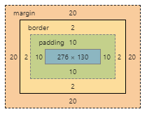

**Chrome Developer tools**

Use Chrome inspect to look at the page we made

Elements

Styles, Computed

Console

Show CSS

Go to <https://www.techtalentsouth.com/> Show errors and warnings

**Download homework images**

Titus go to Intro to CSS Homework

Click the 2 images then right click Save As C:\TTS\Day 2-Intro to CSS\images

**CSS Exercises (if time permits) (Take picture)**

* Add some more states to our places list, mark them as northern or southern states. Set the northern states gray and the southern states green
* Create a second .css file called headers.css and link it to your html page. Move your header selectors to this file.
* Create a child page and add a link to it from your main page and a home link to return. Include your css file on this page and add several tags to see the css formatting.

***End of CSS Class***

**8:30 At End of Class (leave time for installs if needed)**

Release Homework

Have them do Wells Fargo button

Show them banner homework - my solution for banner

( Didn’t know how to do it, but I knew I could figure it out.)

Took about an hour

Limitless solutions

Vague requirements are the norm in programming

We covered what they need, but we didn’t create a banner

Show them <https://www.w3schools.com/css/css_navbar.asp>

Did everyone get Java Pre-Course Work.pdf?

Review Java install if time permits C:\Users\Chuck\OneDrive\TTS\Code Immersion Java\Day 1 - Intro to Programming & Intro to HTML\Intro to programming\Java-install.docx

Review Eclipse install if time permits C:\Users\Chuck\OneDrive\TTS\Code Immersion Java\Day 1 - Intro to Programming & Intro to HTML\Intro to programming\Eclipse=install.dox

Next week Bootstrap